POSITION TITLE: Racine Zoo Conservation Education High School Intern

REPORTS TO: Conservation Education Manager

POSITION CLASSIFICATION: Internship for high school students; $150 stipend available upon completion of internship

PURPOSE: To learn about current issues in conservation and learn to interpret them to guests.

DUTIES:

- Interns will participate in eight training dates with Conservation Education staff on Saturday mornings throughout the internship. This will include both structured learning and hands-on experiences.
- Interns will commit to 16 hours of weekend shifts over the course of the internship. These shifts will involve engaging the public in conversation about conservation initiatives with the goal of galvanizing people to take action. This may include use of biofacts, providing education and outreach at Zoo-sponsored conservation days, and assisting with research and program development.
- The internship will culminate in a final project where students will identify a current problem related to earth or biological sciences, and then propose solutions to their chose problem which can be incorporated into future educational programming.

Classes will take place from 10:00am-12:00pm on Saturday mornings Nov. 2, 9, and 15; Dec. 7 and 14, and Jan. 4, 11, and 18. Weekend shifts will be available those weekends at 12:30pm-1:30pm Saturday and 12:00pm-2:00pm Sunday. Other shifts may be available to help with special events at the Zoo.

QUALIFICATIONS: We are seeking motivated high school students looking to learn more about and gain experience in careers related to conservation, wildlife, animal care, interpretation, or education. This position requires strong writing, speaking, and organization skills including the ability to multi-task. Proven ability to interact with other staff, guests, and volunteers and to maintain an energetic and positive attitude. Must be willing to work outdoors in all weather conditions.
If applying by email, please put “Conservation Education Intern” in the subject line. Please send a cover letter and completed application. If you choose, you may also submit a resume. Please apply to:
Racine Zoo
Attention: Aszya Summers
Conservation Education Manager
2131 North Main Street
Racine, Wisconsin 53402
asummers@racinezoo.org
Applications due no later than Sunday, October 20th, 2019.
Program made possible thanks to a grant from the Institute of Museum and Library Services.
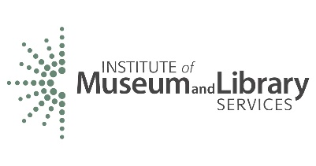

Basic Information
Name: ______________________________________________________

Date of Birth: _________________________________________________
Year in School: _______________________________________________
Related Coursework: __________________________________________

____________________________________________________________

Questions
Where do you see yourself in 10 years?

Why do you want to intern with the Racine Zoo?

Why is conservation important?

Why is it important to educate the public about conservation issues?

What do you do to help conserve the Earth?

Are you comfortable with public speaking?

Are you comfortable working with children of all ages? Do you have any experience working with children?

What is your favorite animal and why?

